For packet Tracer 7.2.1 & earlier

The latest version of packet tracer no longer requires JAVA, therefore the fixes below are not required.

Guide For Netacad Chapter Exams

Some Netacad chapter exams will use packet tracer as an exhibit for some questions.
If the exam does require packet tracer it will use Java Web Start to detect that it is installed and to run it when required. A JNLP file will appear at the bottom of your browser that you will need to click and run. Ensure that you allow Java to run when requested (likewise for flash if prompted).

The following notes are to help you with any packet tracer issues that might come up.

Within OP
Firstly to guarantee minimal issues with packet tracer, it is best to use the OP labs (e.g. D313) for your Netacad chapter exams. If you do, then make sure to use Firefox as the OP lab install of Chrome will not work with flash.

Netacad Exams outside of OP
If you wish to do the chapter exam outside of a lab (at home), then take note of the following:

Ensure you have the latest version of Java, Flash & Packet Tracer (version 7.2.1) installed on your PC.
Packet Tracer can be downloaded from www.netacad.com from under the resources drop list.

JNLP association

If the JNLP file is not running / opening correctly, then it may be it is not associated to Java Webstart correctly.
To associate the JNLP file correctly, first save the JNLP file locally.
Locate the JNLP file (in your downloads folder), right click it and choose ‘open with’.
On windows 10 choose ‘More apps’ then ‘Look for more apps’ which allows you to browse for the application.
Go into your Java folder (see screenshot below) and select javaws (Java Web Start).
Restart your browser, login to Netacad and retry the chapter test, remember to click (run) the JNLP file when it appears.

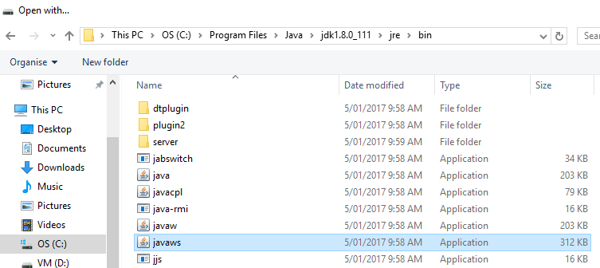

Testing your home environment
You can test if your PC is setup fine for running packet tracer for Netacad chapter exams here:
https://assessment.netacad.net/check/check.html
Note this can take a few minutes
You will be presented with a summary screen indicating if everything is ok

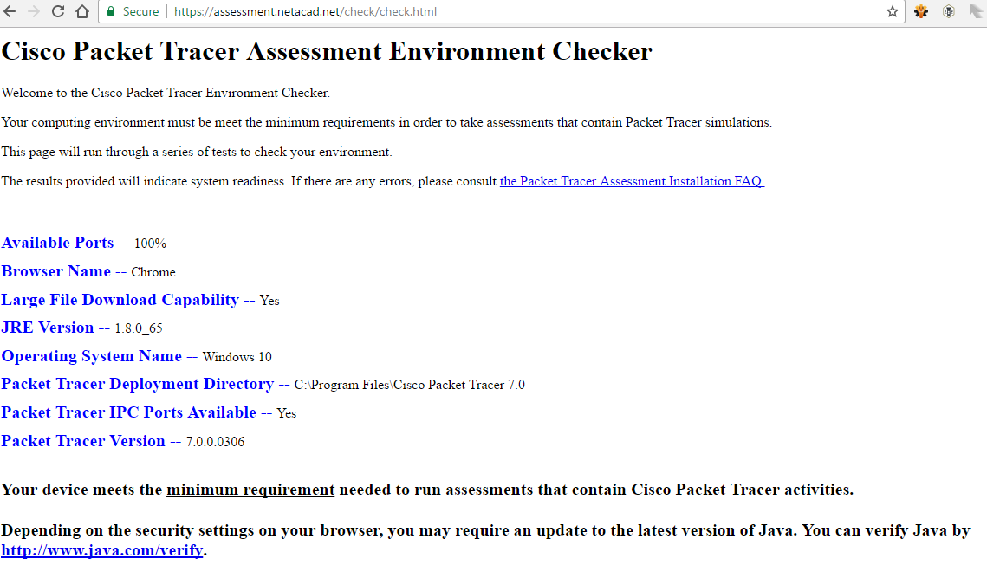

Tip
If you do run into issues, you can complete all the non-packet tracer questions and then close your browser which stops the clock, you can then finish the exam in an OP lab room.

Java Security (usually not required)

You may also need to modify your Java security settings. This can be done through accessing Java within your PCs control panel, then choose the security tab and add a site exception for:
https://assessment.netacad.net
This has already been done for the OP lab PCs.

It may look like this
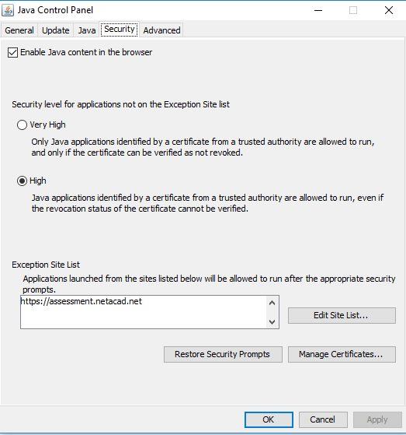

Or alternatively it may look like this
